**VIDEO CALLING APP**

**PROJECT SYNOPSIS**

OF VIDEO CALLING APP

**BACHELOR OF TECHNOLOGY**

COMPUTER SCIENCE AND ENGINEERING

SUBMITTED BY (12pt.)

VARTUL BAHUGUNA (1901920100316)

Sept. 2020 (12pt.)



SUPERVISOR: Mrs. SHIKHA SINGH

Designation :

# DEPARTMENT OF COMPUTER SCIENCE & ENGINEERING

**GL Bajaj Institute of Technology & Management (U.P.) - 201306 (16pt. bold)**

**ABSTRACT:**

In the era of growing network and tech where internet is available to everyone and can fit into their pocket, small meetups can go on virtually without the physical presence of person. This project aims to create a peer to peer connection between two remote device and enable live video streaming for both ends. With the help of this project we aim to understand the working of live video streaming between two devices.

The project is divided into 3 parts:

* UI
* Data Base
* Backend

**MOTIVATION:**

In this era of pandemic when everyone is adopting the methodology of work from home, small meetings or discussions can take place virtually. Live video chat is becoming more popular and there are no signs of that changing any time soon.

We have seen that there are many disturbances like audio problems, video glitches, connection error, etc... So, to know about the causes of all such errors and to find a way to overcome those we are making this project.

**LITRETURE REVIEW:**

|  |  |
| --- | --- |
| **Pros** | **Cons** |
| Video conferencing is usually cheaper and faster than in-person meetings | Risk of technical issues |
| It also makes it easy to exchange data in real time so presentations can reach multiple people in multiple locations | Dropped connections, camera malfunctions and choppy video streams can quickly make a video conference frustrating |
| Video displays professionalism | Video glitches can make a conference look unprofessional |
| When agents are on a video chat with a customer, they have to be fully focused on the customer and resolving their issues | Technology can be vulnerable to Hackers threats |
| Supports Screen sharing | Maximum 4 people can join the call |
| A nice virtual environment is created for meetups and you can contact anyone in your contact list. | Even though you can see everyone on the chat, you’re still removed from actual human contact, which can lead to some miscommunications. |

**OBJECTVE:**

The main purpose of video conferencing is to enable face-to-face communication between two or more people in different locations. It is a popular alternative to phoneconferencing for businesses and provides individual users with an inexpensive means of communication with distant friends and family.

**METHODOLOGY:**

The main reason that an app gains its technology is by its UI design. This app has an interactive, simple and easy to understand UI. Authentication steps also sometimes put out a user to use the app, so the authentication steps for the user are kept simple and yet secure.

Screen sharing had always been an important and an interesting feature. Keeping this in mind we have added a screen sharing feature.

WebRTC is a free, open project that provides browsers and mobile applications with Real-Time Communications (RTC) capabilities via simple APIs. The WebRTC components have been optimized to best serve this purpose.

But there are many other things which we need to do as WebRTC is not enough for complete implementation.

Other things are:

* Signalling
* STUN Server
* TURN Server

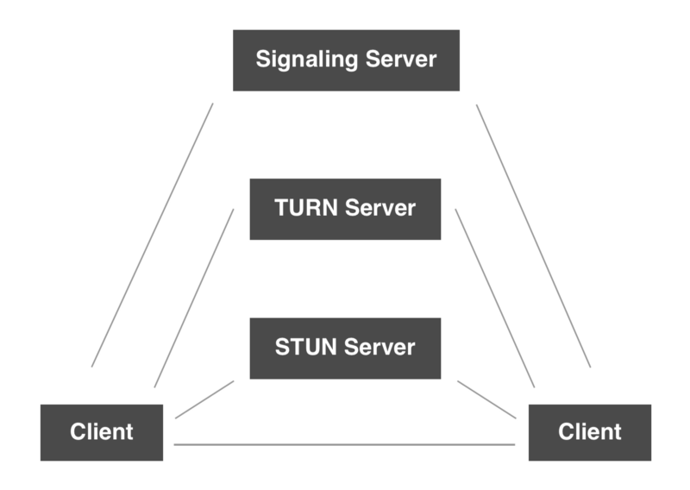

#### Signaling:

What is Signalling?

In order to set up a call between two clients, both the clients must conform to each other by sending key data, messages, metadata about the media. Over signalling, we do these things.

We can use WebSocket for the purpose of signalling.

It is just used to know that these two clients want to connect to each other for the call.

#### Peer to Peer Connection:

After signalling, we need to connect both the client peer to peer. And for connecting, we must have the public IP address of both the clients.

So, in order to get the public IP address, we use the STUN Server.

#### STUN Server:

STUN Server is used to get the public IP address.

Why need a public IP address?

A **Public IP Address** is an IP address that is globally unique across the Internet. Only one device may be in possession of a public IP address.

A **Private IP Address** is an IP address that is not globally unique and may exist simultaneously on many different devices. A private IP address is never directly connected to the Internet. Devices that possess a private IP address will be in their own unique IP space (e.g. different companies or domains).

The NAT(**Network Address Translation**) provides the local IP address of the device which can’t be used publicly to connect peer to peer. And for WebRTC, we need to have the public IP address. STUN Server provides that.

If everything is fine, we get the public IP addresses of both the clients and then, we connect both the clients through WebRTC to start the call. WebRTC handles all the media streaming.

#### TURN Server:

TURN Server is used to connect both the clients if peer to peer fails by acting as a mediator. Basically, it takes the data from one client and sends it to another client. So, it’s job is to relay the media.

This way, the two clients start talking to each other.

The other small data which are not related to media like a client cuts the call, any setting changes, messages and etc are sent over the signalling process.

To overcome all these tasks, we are using QwikBlox SDK that’s build upon WebRTC and also acts as a PaaS over many platforms like Android, Flutter, iOS, etc. We are also using it for backend that will be taking care for authenticating the user and manage all other tasks.

**Hardware/Software/Language Requirements:**

* 4GB RAM (min.), 8GB RAM (Recommended).
* Android Studio
* QwikBlox SDK
* Languages: Java, XML
* Room Lite Database.
* Firebase

**BIBLIOGRAPHY**:

* <https://docs.quickblox.com/docs/android-quick-start?_ga=2.228205854.2067812581.1604251576-1128658861.1603619855>
* <https://developer.android.com/docs>
* <https://www.youtube.com/watch?v=d6bG2bMt2us&list=PLaoF-xhnnrRUzkfXXL4kA9D2IklWZ0WZO>
* <https://www.cleveroad.com/blog/how-to-make-a-video-chat-app#video-conferencing>
* Other blogs and posts on Medium and Quora.